<https://www.sciencedirect.com/science/article/pii/S0304387820301553?via%3Dihub>

2016 data

2019 data [Ethiopia Mini Demographic and Health Survey 2019 - Key Indicators [PR120] (dhsprogram.com)](https://www.dhsprogram.com/pubs/pdf/PR120/PR120.pdf)

Website for datasets: <https://dhsprogram.com/data/Guide-to-DHS-Statistics/Age_at_First_Marriage.htm>

Refer to the STATCOMPILER LINK on the site to get the graphs and stuff!!!

Format:

1. **Introduction** - **Guneek**

* Summary of original paper & its critique
  + Critiques of assumptions that the author makes in the paper
    - Possible critiques about assumptions made in the paper: exogenous timing of reform by region - how would this change the data
  + Include what the author’s methodology is and her purpose of doing so
    - I.e., what does the author do and WHY

1. **Background & Motivation - Guneek**

* Discuss what our research paper does differently than the original paper and explain WHY (i.e., motivation behind our paper) we chose to do it this way (so, the specific methodology we use in our paper and the research design)
* Emphasis on the motivation behind our research paper - explain the purpose we are trying to achieve with our specific extension - why we chose this way of extending the original paper
* Discuss briefly as to what our extension is exactly about (in a few sentences)

Methodology & Critiques

* Extension and conclusion
  + Methodology
    - Why we did what etc.
  + Findings

Possible critiques

* Assumptions made in the paper
  + exogenous timing of reform by region
    - How does this change the data?
  + How the paper accounting for other policies and shocks

Methodology Section

*Explanation of the extension, background of the paper, and goals and expectations*

The current paper explores the effect of a child marriage law in ethiopia on the age of when a women first gets married. The paper performed an event study and a different and difference analysis, to observe the change in age of a first marriage for women. The law was introduced in 2000. The paper uses the years 1990-1999 as a reference point before the marriage law, and 2000-2009 to observe the causal impact of the policy.

To see the long term effects of the marriage law, the extension will perform a similar regression. In the paper, we will use an updated dataset on years 2016 and 2019 to capture the long term effects of the law. We will perform the same regression to observe a difference and difference between not only before the law in 1990-1999, but also make any observations of the changes between 2000-2009.

The data used:

**2016**

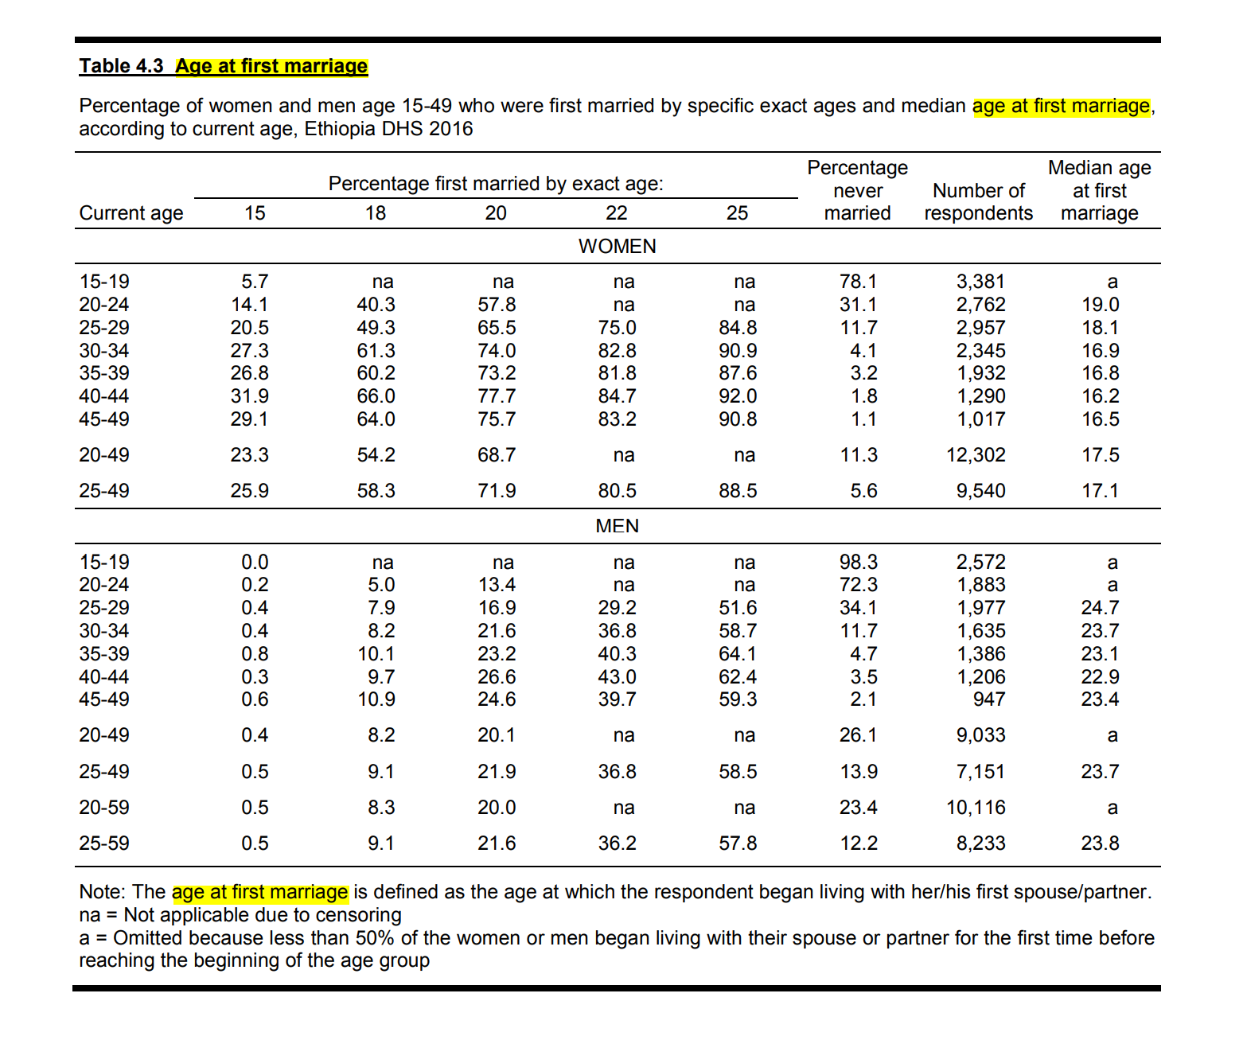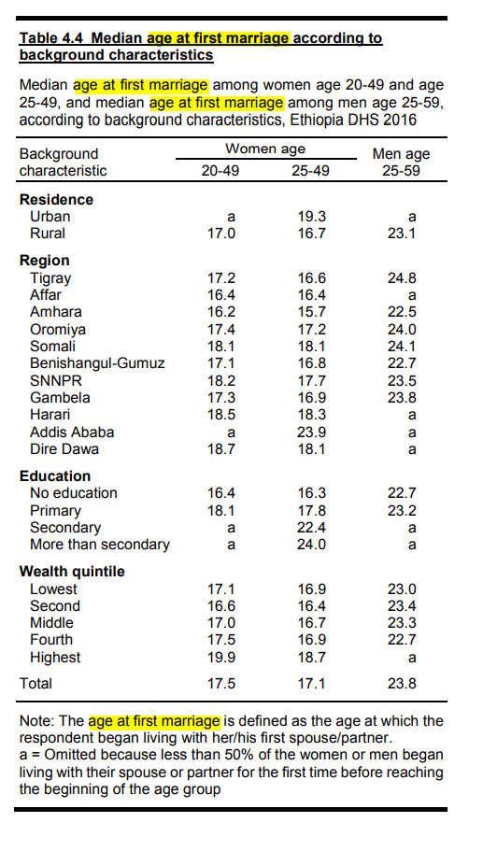

**2019**

**NOTE: The 2019 data does not include information about the age of first marriage, instead, look at the proportion of the women married in the lower age groups to affirm our extension’s conclusions. Maybe also compare this to the original study’s conclusions.**

*The regression*

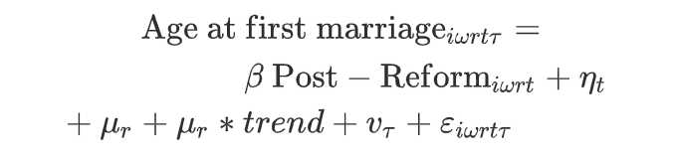

The paper uses the following regression to estimate the causal impact of the marriage law. The treatment group in the difference in difference model is the women married after the reform, while the control group is the women married before. In the regression, the dependent variable is the age at first marriage of a woman, i. The w, t, r refer to the district (woreda), region married, calendar year of marriage and year surveyed respectively. The Post - Reform is an indicator to whether the marriage took after the “in region r, and year of marriage (ηt), region (μr), and year of survey (ντ) fixed effects are included.” The author also includes region specific linear time trends , and a vector to represent other controls; ethnicity fixed effects, rural dummy variable, and age at the survey. The beta coefficient captures the treatment effect in this regression.

**Our data (see figures and tables in google drive)**

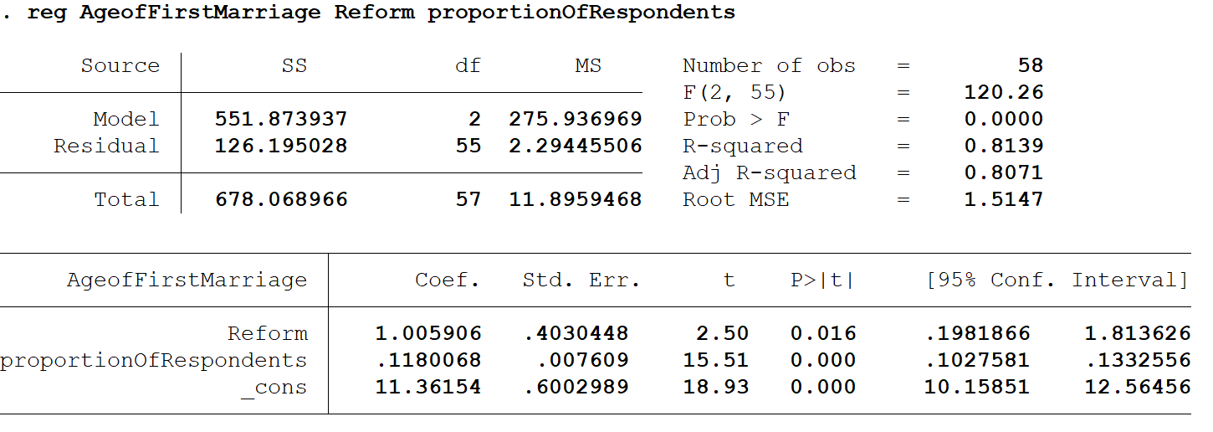

Explanation of our regression

Findings and results

The limitations and critiques of our extension

Limitations / Critiques

~~The additional data we found for our extension was only available for the year 2016 on the DHS website.~~ ~~Although some data was available for 2019, it did not contain information on the age of first marriage which was crucial for our analysis.~~

**\*\*Don't need to state that this was crucial for our analysis it makes the extension we have look weak - so mention some other limitations like the ongoing data collection or in particular, how they stopped at a particular month in 2019 for the survey collection so there is some limitation regarding that aspect; (2016 provides the different results we need in comparison to the author’s which was our main purpose of the paper)**

Limitations:

Currently, the data on Ethiopia that has not been used in the original paper is available on the DHS website for 2016 and 2019. However, while the data is fully available for the year 2016, the processing and analysis of the data collected is still ongoing for the year 2019. Thus, the 2019 survey data has not been published on the DHS website. Furthermore, while the fieldwork, the process by which the data was collected, was conducted from January to June in 2016, it was only conducted from the months of March to June in 2019, adding further limitation to the availability of data from 2019.

While the original regression incorporated various fixed effects and linear time trends, our much simpler regression only accounts the changes in marriage ages to the changes in the law, thus reducing the magnitude of the variance in the age of marriage that can be explained by the independent variables in the model.

Critiques:

In order to account for factors that affect marriage age, the author relied on region-specific linear time trends to control for economic conditions, changes in norms over time and changes in educational attainment over time in specific regions. However, the author did not elaborate on what metrics were used to measure the time trends. To reduce the interference of omitted variables, the author should have focused on specific factors that are known, or are likely, to influence the age of marriage in these regions, such as the poverty rate. Furthermore, since the research examines child marriage in Ethiopia on a country-wide level, the author should have accounted for the country-wide linear time trends.

The accuracy in the measurement of the impact of the marriage law on economic outcomes such as education may have been corrupted by imperfect compliance with the law. As mentioned in the paper, as recently as 2016, 18% of 17 year old girls were already married. For women aged 18, the proportion was 35%. There is little evidence to suggest that the violations have been widely prosecuted. Since our analysis utilizes the same methodology, this problem affects our analysis as well.

As mentioned earlier, our simplified regression does not take into account factors that may affect age of marriage besides the changes in the law, and the relationship between the dependent and independent variables may be overstated.

….

Script for my part

**Methodology of the Extension**

Alright!! I’ll be covering our extension’s methodology and findings, and how we accomplished our goal of extending the data.

**Goals with the extension**

The goal with our extension was to expand on more recent data. We did this - as Guneek mentioned, to learn of the long term impacts of the marriage law implemented in 2000. With the original paper ending its case study in 2009, we decided to expand by looking at the 2016 dataset. To outline the long term effects of the law, we conducted a difference and difference study to isolate the effects of the law between 2000-2016. The datasets we used contained the proportion of respondents per age group, and of course the age of first marriage (used exact ages in intervals - 15,18,20,22,25).

**Our model**

In order to formulate a difference in difference model, we had to create several dummy variables to represent the changes before and after the reform. Recall we were looking at the most recent dataset - 2016, and the initial dataset released in 2000 before the reform was implemented. We will treat respondents in 2016 as the treatment group and respondents in 2000 as the control. This is suitable because the study conducted in 2000 contains information from a 10 year period before the reform (1900-1999), while the respondents in 2016 have felt the effects of the reform for 16 years.

First, we created the “Reform” variable, which is a dummy indicating whether the study was conducted before or after the reform. The dummy will activate for proportions made after 2000 (2016) - the treatment group, and will turn off for values in the control group (2000). Since the time of reform is the same as when the reform was implemented, it is sufficient to use this as the difference in difference estimator alone.

In addition, we will use the “proportion of respondents” to outline the changes in the distribution of how many respondents there are when a change in first marriage increases or decreases. This variable is used to outline the age of respondents at the time of surveying - and will be used to judge the changes in proportion in relation to age of first marriage. In addition to the difference in difference model, we created dummy variables for the age of each respondent to outline trends of how the age of respondents varies with the proportion of respondents of the particular age of first marriage.

**Model**



**Alpha beta gamma for var names**

Hence, we are left with our model. The Beta variable to note will outline the effects of the law on the age of first marriage. Alpha represents the fixed effects and gamma represents the effects in the changes of proportion of respondents on the age of first marriage. For example if more responders are present when the age is lower or higher. We will use this model to answer two questions:

* How does the reform affect the age of first marriage?
* How does the proportion of people in those age groups affect the age of first marriage?

**Extensions & Findings**

Now let's go over what we found with our model.

**What were some trends we observed?**

Firstly, what were some trends we observed overtime between 2000 and 2016?

**Median age of first marriage (women) 20-49**

Here is our first graph, which outlines the median age of first marriage for women, who were 20-49 in the survey. As we can observe, there is an upward trend in the median age of first marriage from 16.4 to 17.5, a 1.1 increase in age from 2000 to 2016.

**Median age of first marriage (women) 25-49**

In our second graph, similar to the last one we now outline the median age of first marriage for women who were 25-49 in the survey. This is important as it highlights older individuals who may not have been married after the reform. Here we see another upward trend - indicating that the median age of first marriage is increasing. Specifically, 16 in 2000, to 17.1 in 2016, a 1.1 increase again.

**Women first married by exact 15**

Now the next graphs - this and the next ones will outline the changes in the proportion of people who were married by an age labeled at the top. In this slide it outlines the proportion of respondents with their ages, of which got married by exactly 15. We can observe that the proportion of those married by 15 are much higher in the older generations, a 37.1 percentage peak of those aged 45-49 compared to 8 percent of those aged 15-19 in the same year (2011). There is a general downwards trend for all ages however, with all ages lowering the proportions they married by 15 by 2016 compared to those in 2000. The younger generations take a more drastic decline from 2000-2016, as likely the law is most impactful for them. Respondents aged 15-19 dropped from 14.4 percent to 5.7 percent from 2000-2016.

**Women first married by exact 18**

Next, this graph details respondents who were first married by the age of 18 with their respective ages at the time of survey. The most interesting observation is the sharp increase in proportion across all ages listed in the graph. For example, respondents aged 20-24 saw an increase from 14.4 to 40.3. This would indicate from ages 20-49 there is a greater emphasis on marriage at around 18. Yet still, we still see a drop in the proportion of those married by age 18 from 2000-2016.

**Women first married by exact 20**

This graph details respondents who were first married by the age of 20 with their respective ages at the time of survey. The proportion increases slightly for all ages, however not as significantly as the switch from age 18 to age 20. There is a slight downwards trend again, however less so compared to previous ages. The oldest generation sees the sharpest decline here, most likely indicating the respondents were married younger than 20 before they got married.

**Women first married by exact 22**

Now, this graph details respondents who were first married by the age of 22 with their respective ages at the time of survey. With the majority of proportions above 85 percent, we can observe that the majority of ethiopians get married by 22. There is a slight downwards trend again, however it is becoming clear that the effect of the law is becoming less prominent as age increases for the first marriage.

**Women first married by exact 25**

Finally, this graph details respondents who were first married by the age of 25 with their respective ages at the time of survey. A very slight increase in proportion again, signifying most ethiopians are married before this point. The downward trend is even less pronounced and not as applicable to the age 30-34 group, but is slightly apparent otherwise through all generations especially from 2011-2016. Older generations seem to not be as affected by the reform as very young generations earlier.

**Our Model**

Now we finally can observe what our regression accomplished.

**Stata Output**

Here is the stata output for our regression. Firstly, we can observe that the reform dummy variable coefficient - beta is positive. This indicates that the age of marriage increases by 1.005905 on average when the law is active. This is in line for what we saw with the trends lines before, with the downward trend from 2000-2016, especially for younger generations. We can also note that this value is statistically significant, indicated by the P>[t] section, where it is 0.016 (which is greater than 0). The proportion of respondents’ coefficient - gamma, is also positive - indicating that as the proportion of people increase, the age of marriage also increases, at .118. This is a small value, and indicates that the proportion of Ethiopians get married younger, which is also in line with our trend graphs (majority were married by 22). Nevertheless, this value is statistically insignificant.

**Summary of Findings**

* There was a downward trend for when law was in effect, especially for younger ages
* Statistically significant coefficient for reform variable and a positive correlation. Therefore the reform did have an effect on age of first marriage it increased it
* Proportion of respondents had a positive correlation - small increases in age of marriage, indicates the proportion is mostly concentrated at lower ages
* This was supported by trend graphs, older respondents were not affected much by the law and got married younger more often